**AI-INTEGRATED SMART HEALTHCARE KIOSK FOR VITAL MONITORING**

**AND DIABETIC RISK DETECTION**

**Problem Statement: Product Category Creation for Healthcare Kiosks in India**

**(Intel Unnati Submission – July 2025)**

*Name of the Students: RAHUL BHATT (220051601094), SAKTHI SWETHAA A (220051601099)  
 MUHAMMAD NAINA AASIF (220051601080)*

*Name of the Mentor: Dr. S. KALAIVANI, AP (Sel. Gr)/ECE*

*Institution: BSA Crescent Institute of Science and Technology*

*Contact:* [*skalaivani@crescent.education*](mailto:skalaivani@crescent.education)*; 9600099904*

[rahulb9340@gmail.com](mailto:rahulb9340@gmail.com); 8762912191

**PROJECT OVERVIEW & VISION**

**1. Problem Statement**

Access to basic healthcare diagnostics remains a challenge for rural and semi-urban areas in India. There is a dire need for affordable, self-service, and AI-enabled solutions that ensure early detection and monitoring of health conditions, reducing the burden on tertiary hospitals and enabling timely interventions.

**2. Proposed Solution**

We propose a smart healthcare kiosk—a product category that bridges primary health screening and early disease detection at the point of care. *The work has been carried out in two phases*

**Phase 1:** Development of kiosk

**Phase 2:** AI based diabetic foot ulcer detection

Our kiosk:

* Collects personal info via Fingerprint sensor.
* Acquires vital signs: Body temperature, blood pressure, heart rate, SpO₂, (height and weight) BMI, ECG, height, and weight.
* Uses cloud-based storage with timestamped, patient-specific data.
* Generates an auto-formatted health report accessible via a mobile app.

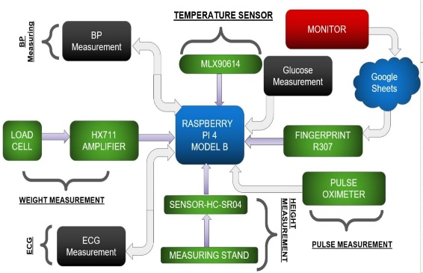 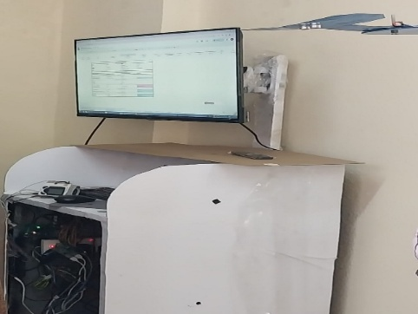

**Block Diagram of Proposed Healthcare Kiosk Implementation of Healthcare Kiosk**

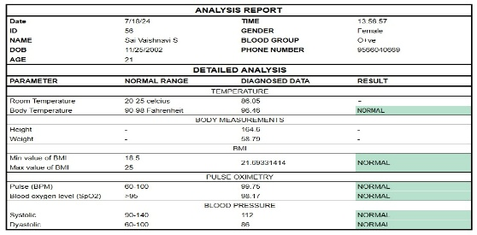 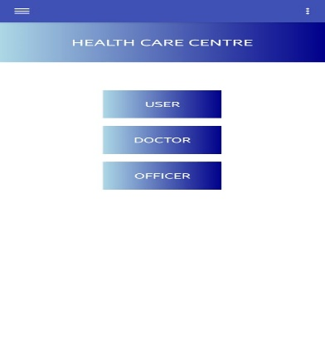

**Analysis Report generated Mobile App**

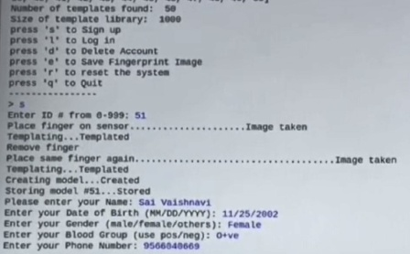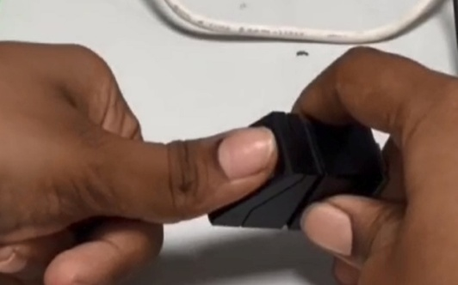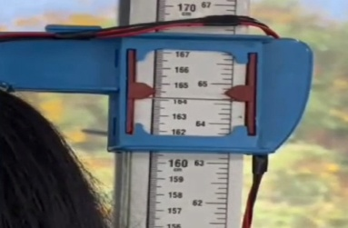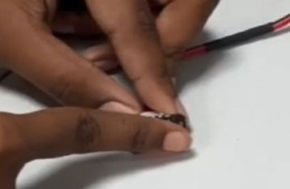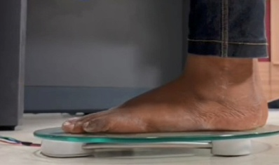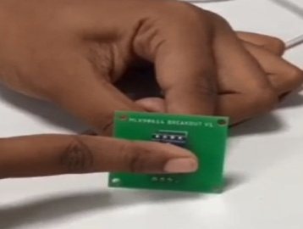

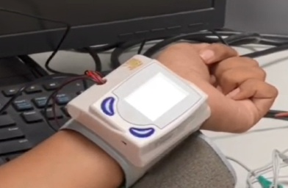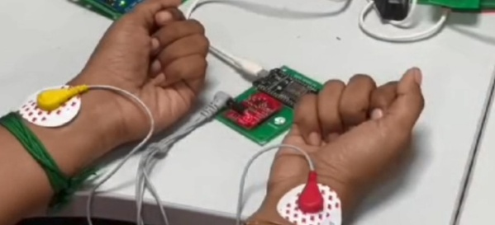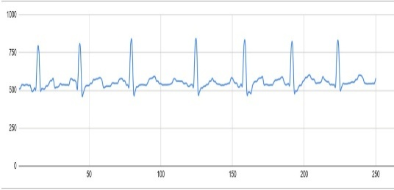

**Personal Data and Vital Parameter acquisition**

**3. Innovation Extension (Phase 2): AI-Based Diabetes Detection**

To enhance diagnostic capabilities, we have integrated a **deep learning model to detect diabetes via thermal foot imaging**, targeting **diabetic foot ulcer** identification—an early sign of neuropathy.

Dataset preprocessing using thermal images taken from the following database.

* <https://www.kaggle.com/datasets/vuppalaadithyasairam/thermography-images-of-diabetic-foot/data> For Validation and Testing
* <https://share.google/kXPUz7BqKpNU2QoRh> For Testing

*Total Dataset Breakdown:*

1. Training Set - Control Group: 720 images, DM Group: 724 images, Total (Train): 1,444 images
2. Validation Set- Control Group: 170 images, DM Group: 172 images
3. Test: Control Group: 90 images, DM Group: 93 images

* <https://share.google/RfyWizHMtk3MHFkMd> For Testing with another dataset

*Models compared:* **MobileNetV2, EfficientNetB0, ResNet50V2**.

**TECHNICAL IMPLEMENTATION**

**1. Hardware Components**

|  |  |
| --- | --- |
| **Components** | **Function** |
| Raspberry Pi 4 | Central controller & computation |
| Fingerprint Sensor (Adafruit R307) | Patient authentication and login. |
| Infrared Temperature Sensor (MLX90614 with ESP8266) | Body and ambient temperature measurement. |
| Load Cell + HX711 | Weight measurement |
| Ultrasonic Sensor | Height detection |
| PTI120-9Hz (Thermal Camera) | Diabetic foot imaging |
| Pulse Oximeter (MAX30102) | Heart rate (BPM) and SpO2 |
| Blood Pressure Module (Serial BP Monitor) | Systolic and diastolic pressure readings. |
| ECG Module(AD8232) | Serially connected, retrieves and uploads ECG wave data. |

**2. Software Stack**

* **Languages:** Python (sensors + AI)
* **ML/AI Tools:** TensorFlow, NumPy, Scikit-learn, Matplotlib, Seaborn, OpenCV
* **Cloud:** Google Sheets API using Google Apps Script for storing patient records automatically.
* **App Stack:** PyCharm

**3. AI Model for Diabetes Risk Detection**

* **Input:** Thermal foot images (infrared format)
* **Goal:** Detect early-stage diabetic foot complications
* **Models Evaluated:** ResNet50V2, EfficientNetB0, MobileNetV2 *(Selected based on accuracy and performance)*

**Accuracy Achieved (MobileNetV2): ~95%**

***Model Accuracy Graph*** *of MobileNetV2, ResNet50V2, EfficientNetB0:*

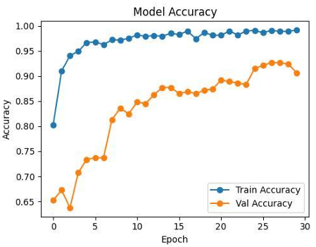 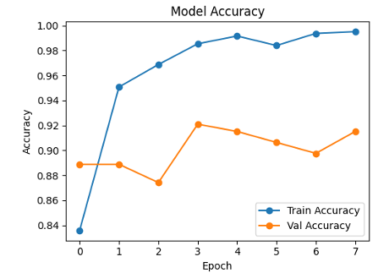 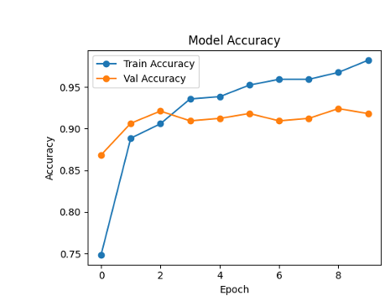

***Model Loss Graph*** *of MobileNetV2, ResNet50V2, EfficientNetB0:*

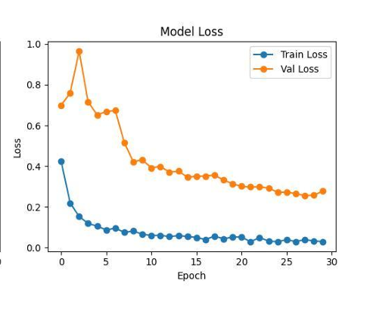 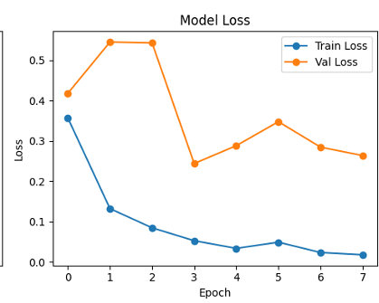 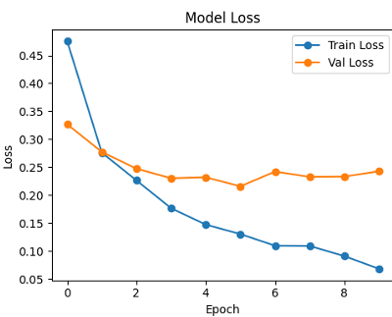

***Confusion Matrix*** *of MobileNetV2, ResNet50V2, EfficientNetB0:*

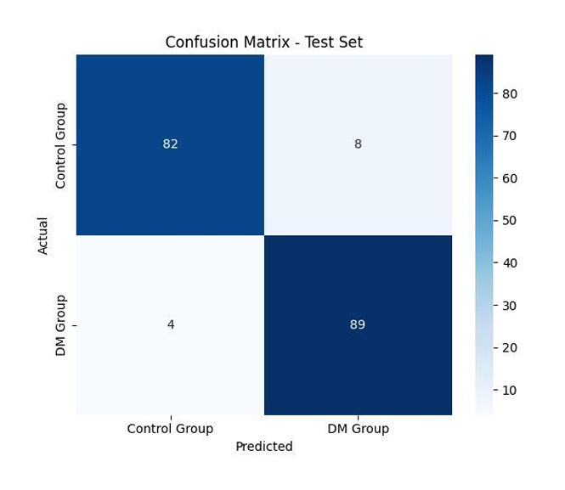 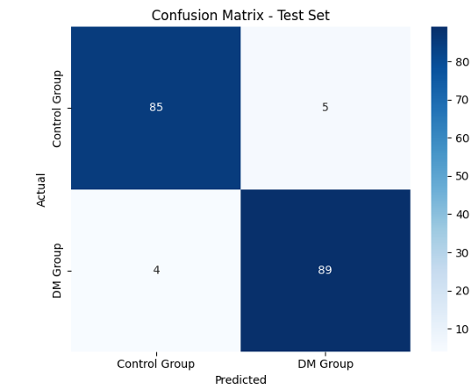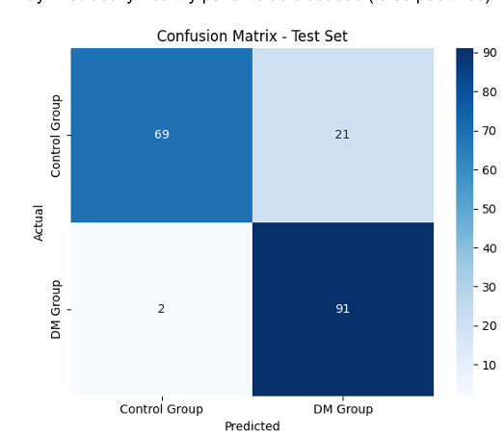

***Model Comparison Chart:***

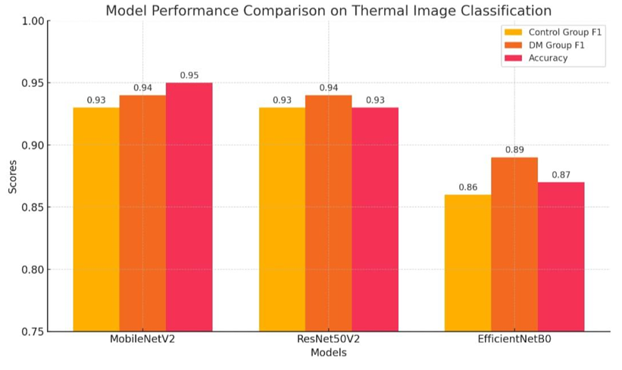

* **MobileNetV2 is better that other models with accuracy of 95%**

**Result analysis:** (images taken from data link: [https://share.google/RfyWizHMtk3MHFkMd](https://share.google/RfyWizHMtk3MHFkMd%20) )

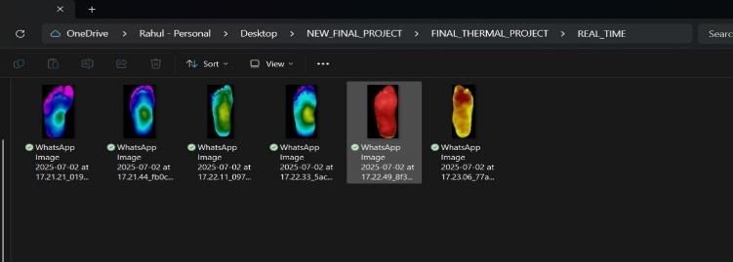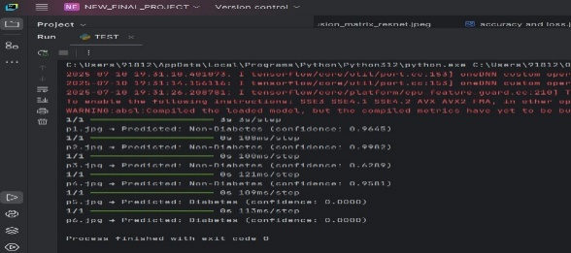

**SIMULATION RESULT SHOWING DIABETIC AND NON-DIABETIC IMAGES**

**Real time implementation using thermal camera (AD8232):**

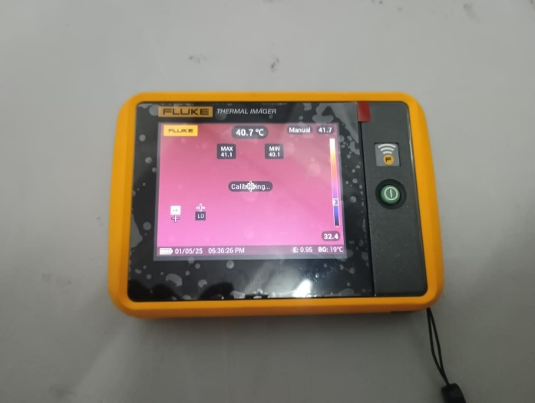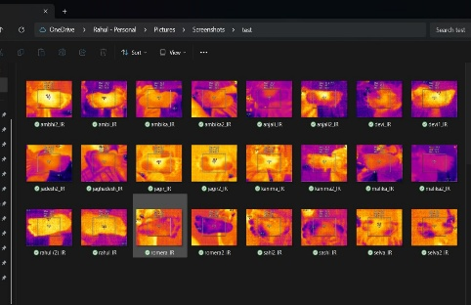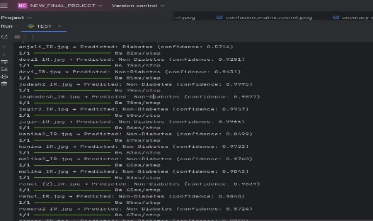

**SIMULATION RESULT SHOWING DIABETIC AND NON-DIABETIC IMAGES**

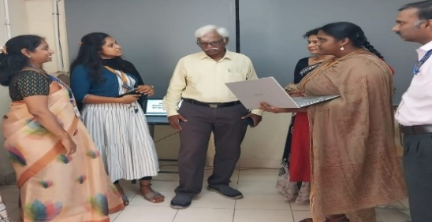

**Result discussion with Dr. Thayalan Kuppusamy, Consultant Medical Physicist Dr. Kamakshi Memorial hospital, Chennai & Former Professor, Madras Medical College**

**IMPACT, SCALABILITY & ROADMAP**

**1. Societal Impact**

* **Rural Health Empowerment:** No need for specialist presence.
* **Accessible:** Suitable for semi-urban PHCs, community health centers, and camps.
* **Affordable Health Screening:** Costs less for screening.
* **Data-Driven Public Health:** Real-time cloud analytics.

**2. Alignment with National Missions**

* **Viksit Bharat 2047:** Technology-led governance for wellness.
* **SDG 3 – Good Health and Well-Being:** Focused on universal health coverage.
* **Digital Health Mission:** Aadhaar-linked patient data history & interoperability.

**3. Future Roadmap**

|  |  |
| --- | --- |
| **Timeline** | **Milestone** |
| July - Sep 2025 | Real-time integration of thermal camera with MobileNetV2 |
| Oct - Dec 2025 | Edge AI deployment with optimized quantized models |
| Jan - April 2026 | App full release and Pilot deployment in 5 PHCs |
| May - July 2026 | Integration with Ayushman Bharat Digital Mission (ABDM) |

**CONCLUSION AND FUTURE SCOPE**

**1. Key features of proposed system**

* Multi-sensor kiosk platform: Not limited to a single screening function.
* AI-enhanced diagnosis: Moves beyond vitals to risk prediction.
* Offline-Ready: Data sync when connectivity is restored.
* Mobile App Support: For post-screening follow-up and continuity.

**2. Future Work**

* Real-time thermal classification on-device with model quantization.
* Clinical validation of foot ulcer detection via AI inference.
  + - * Expansion to include: Non-invasive blood glucose estimation and AI analysis for ECG signal patterns.